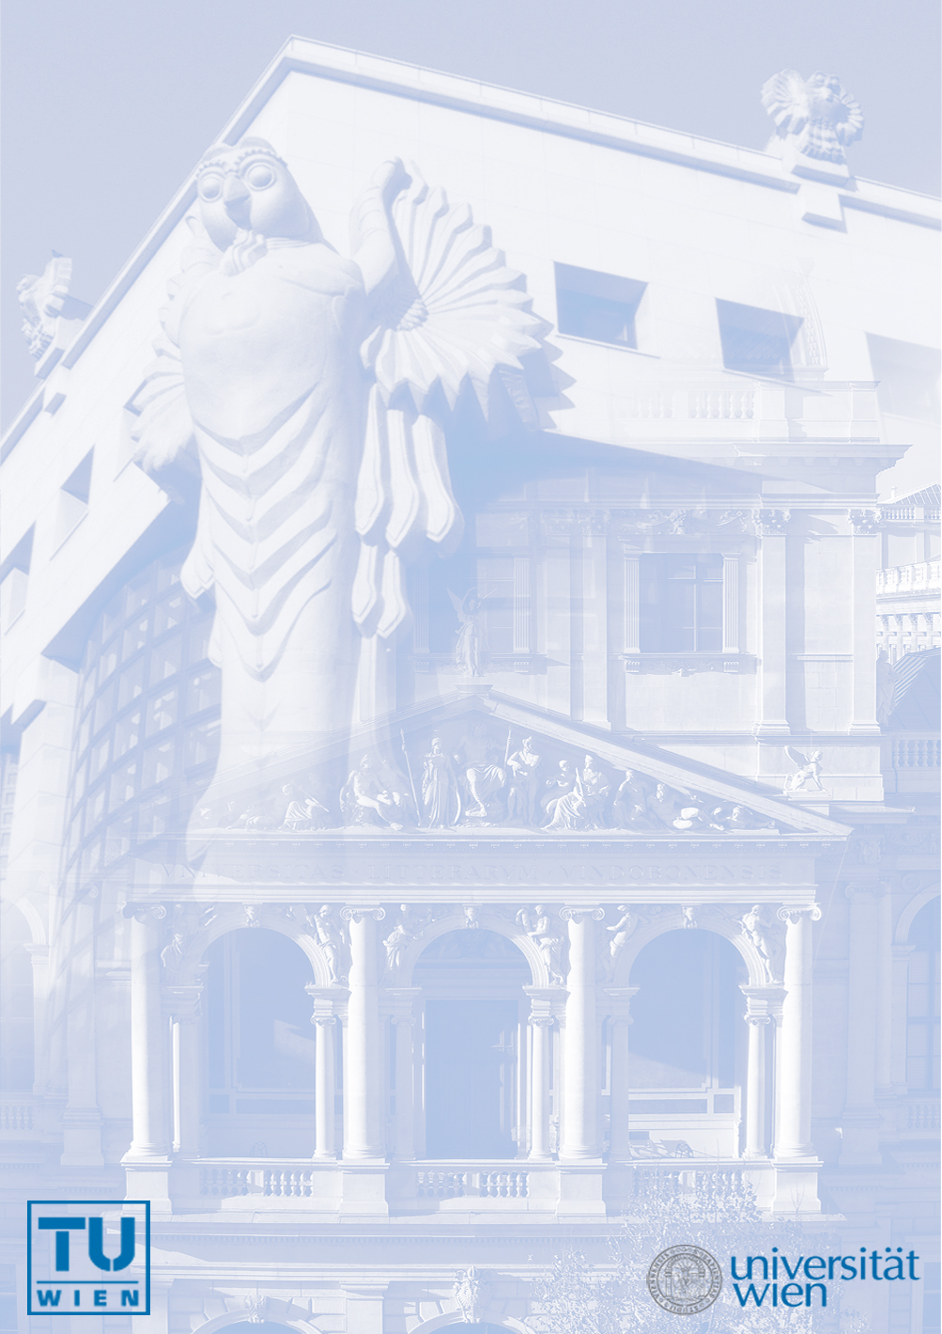
Einladung zum
Wiener Physikalischen Kolloquium

SCHRÖDINGER’S CHIP: DESIGNS FOR SOLID STATE
QUANTUM PROCESSORS USING ELECTRON SPINS

Charles MARCUS
Harvard University, Cambridge

Schrödinger’s cat, half-alive, half-dead, existing in its sealed box in this dual state, illustrates the counterintuitive role of measurement in quantum mechanics, but also how the preservation of quantum properties, which dominate at atomic scales (even at room temperature), become less familiar and even absurd for large multi-particle objects. Building computer chips that can take advantage of quantum coherence and entanglement to allow improvements in computation and simulation is much like the challenge of trying to build Schrödinger's cat, using components that operate near absolute zero. This talk will review progress toward this endeavor, and the interesting new physics that arises in fighting decoherence in solid-state systems.

Montag, 19. April 2010, 17:30 Uhr
(ab 17:00 Uhr Kaffee)

Technische Universität Wien - Freihaus
Hörsaal 5, 2. Stock, grüner Bereich
Wiedner Hauptstraße 8, 1040 Wien

www.univie.ac.at/wpk

