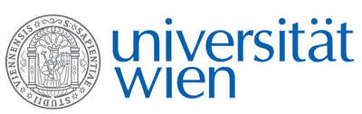 | Fakultät für Physik  Isotopenphysik

I N V I T A T I O N

for a

V E R A – S E M I N A R

with

Dennis Mücher

Institute for Nuclear Physics, University of Cologne, Cologne, Germany

CologneAMS: Status and Perspectives

The Institute for Nuclear Physics at the University of Cologne hosts two AMS setups: the 10 MV FN Tandem coupled to a gas-filled magnet and the 6 MV Tandetron accelerator. CologneAMS is fully integrated into an interdisciplinary research infrastructure at the University of Cologne, enabling fruitful collaborations with the Departments for Geology, for Archeology and for Nuclear Chemistry, among others.
In this talk I will give an overview about the status und future plans of the CologneAMS facilities related to various applications in geoscience, nuclear waste management, and others. The focus of my presentation will be our research on nucleosynthesis of heavy elements in the universe, creating a link between our local efforts to world-leading large-scale radioactive ion beam facilities.

Thursday, 26. January 2023, 16:30 o‘clock

1090 Wien, Währinger Str. 17, "Kavalierstrakt",
1. Stock, Victor-Franz-Hess Hörsaal

R. Golser K. Hain W. Kutschera

