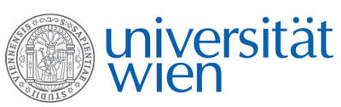 | Fakultät für Physik  Isotopenphysik

E I N L A D U N G
zum

V E R A - S E M I N A R

von

Thibaut DEVIESE

Oxford Radiocarbon Accelerator Unit, University of Oxford, UK

New developments in compound specific analysis
of ancient biomolecules in archaeology
Over the last few decades, mass spectrometry, used for stable isotope analyses and radiocarbon dating, has been evolving very rapidly towards more robust, faster, precise and accurate instrumentation. Such improvement is, however, pointless if we fail to also improve the preparation of the samples to be measured because contamination, even if present at trace level, can affect the data produced and lead to erroneous interpretations.
More precise results can be achieved when radiocarbon dating or measuring isotopic values of specific molecules (e.g. specific amino acids, fatty acids or alkanes) instead of bulk materials, but protocols and instrumentation to do so on a routine basis is not yet widely available in archaeological sciences. The time required to prepare samples and the costs of the solvents are two other bottlenecks in the process that need to be addressed.
This seminar will present new methodologies recently developed at the University of Oxford for compound specific analysis of ancient biomolecules. These will be illustrated by several case studies.

Donnerstag, 09. Januar 2020, 16:30 Uhr

1090 Wien, Währinger Str. 17, "Kavalierstrakt",
1. Stock, Victor-Franz-Hess Hörsaal

R. Golser W. Kutschera E.M. Wild

