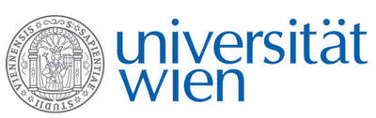 | Fakultät für Physik  Isotopenphysik
E I N L A D U N G
zum

V E R A - S E M I N A R

von

Claudia Lederer-Woods
and
Philip Woods
School of Physics and Astronomy, University of Edinburgh, UK

Per ardua ad astra: The quest for understanding the origin of the heavy elements

The evolution of the universe has left an imprint in the form of the chemical elements. The abundances of elements we see in our solar system, distant stars, meteorites, and in stellar explosions provide us with clues about how the elements came to be produced in a variety of different processes and stellar environments. Dramatic progress has been made in Astronomy from detailed observations of chemical abundances in individual stars, to the first observation of neutron star mergers, which are a prime candidate for heavy element production. This has provided a challenge to nuclear physicists to provide similarly detailed information on the reactions and properties of key nuclei responsible for the formation of these elements. In this talk, we will discuss the different astrophysical processes that are thought to contribute to heavy element abundances, and recent measurements of key nuclear properties and reactions which are crucial for understanding their nucleosynthesis.

Donnerstag, 13. Dezember 2018, 16:30 Uhr

1090 Wien, Währinger Str. 17, "Kavalierstrakt",
1. Stock, Victor-Franz-Hess Hörsaal

W. Kutschera E.M. Wild

