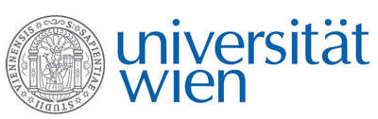 | Fakultät für Physik  Isotopenphysik

E I N L A D U N G
zum

V E R A - S E M I N A R

von

Laura HENDRIKS

Laboratory for Ion Beam Physics, ETH Zürich, Switzerland

Selective ¹⁴C dating of paint components

In the study of works of art, frequently questions arise regarding attribution and authenticity. Radiocarbon (¹⁴C) dating can be a powerful tool for these investigations, however the major drawback of this technique is the necessity of taking a physical sample. Due to the relatively large sample sizes required in the past, ¹⁴C analyses have been restricted to the support material, like e.g. canvas. Thanks to the recent development in AMS techniques allowing for smaller samples, it is now possible to consider dating other materials in an artwork.

Artists’ oil paints are rich in carbon-based material, thus the dating of the oil binder was targeted, which has a high probability of being representative of the time of creation of the painting. Further investigations focussed on the dating of pigments, in particular of lead white, which is a carbonate containing pigment. For this research the combination of analytical techniques allowing suitable sample selection and ¹⁴C dating by state of the art AMS are a necessary prerequisite.

Donnerstag, 08. November 2018, 16:30 Uhr

1090 Wien, Währinger Str. 17, "Kavalierstrakt",
1. Stock, Victor-Franz-Hess Hörsaal

W. Kutschera E.M. Wild

