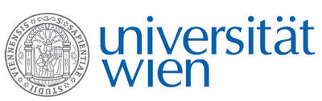 | Fakultät für Physik  Isotopenphysik
E I N L A D U N G
zum

V E R A - S E M I N A R

von

Oana Gâza
and
Tiberiu Sava

Horia Hulubei – National Institute for Physics and Nuclear Engineering, Bucharest, Romania

Research at the Centre for Accelerator Mass Spectrometry (AMS) in Bucharest

The AMS center in Bucharest was founded in 2013, relying on a High Voltage 1 MV Tandetron particle accelerator and the associated sample preparation laboratory. With this multi-isotopic AMS machine the routinely analyzed species are ¹⁴C, ¹⁰Be, ²⁶Al and ¹²⁹I, while recently different tests were performed to determine isotopic ratios in actinide species (^{239,240,242}Pu, ²³⁶U). Radiocarbon remains the isotope with the largest share within our measurements, enabling studies in archaeology, environment and cultural heritage. A niche position in our radiocarbon analysis is represented by the dating of single amino-acids resulting from the separation of collagen extracted from potentially risky bone material using a High Pressure Liquid Chromatography (HPLC) method. Beside the radiocarbon applications we present also some research examples of using isotopic ratios of ¹⁰Be/⁹Be, ²⁶Al/²⁷Al and ¹²⁹I/¹²⁷I for paleo-reconstruction of glaciers and oceanography, respectively.

Donnerstag, 24. Januar 2019, 16:30 Uhr

1090 Wien, Währinger Str. 17, "Kavalierstrakt",
1. Stock, Victor-Franz-Hess Hörsaal

W. Kutschera E.M. Wild

