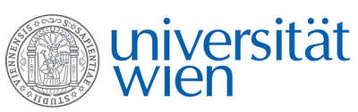 | Fakultät für Physik  Isotopenforschung und Kernphysik

E I N L A D U N G
zum

V E R A - S E M I N A R

von

Sönke Szidat

Department of Chemistry and Biochemistry &
Oeschger Centre for Climate Change Research, University of Bern, Switzerland

How well can we quantify fossil sources
of atmospheric aerosols with ¹⁴C?

Carbonaceous atmospheric aerosols are a substantial fraction of the particulate matter (PM) in ambient air and contribute to climate and health effects of PM. ¹⁴C is an important source tracer, as it allows the differentiation of carbonaceous aerosols that were formed from fossil-fuel usage (i.e., that are ¹⁴C-free) or from PM that originates from contemporary carbon sources. This approach has been used for the apportionment of carbonaceous aerosols into main classes, such as emissions from traffic, biogenic emissions and biomass burning, serving as a basis for regulatory measures of air-quality improvement. This presentation will highlight the potential and the technical requirements of this method. The simplified source apportionment based only on radiocarbon analyses will be discussed as well as the combination with other approaches such as positive matrix factorization using aerosol mass spectrometry.

Donnerstag, 11. Januar 2018, 16:30 Uhr

1090 Wien, Währinger Str. 17, "Kavalierstrakt",
1. Stock, Victor-Franz-Hess Hörsaal

R. Golser W. Kutschera E.M. Wild

