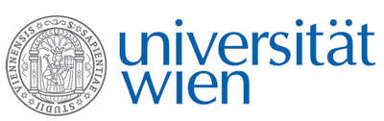 | Fakultät für Physik  Isotopenforschung und Kernphysik

E I N L A D U N G
zum

V E R A - S E M I N A R

von

Dan Berkovits

Soreq Nuclear Research Centre, Yavne, Israel

Physics at the Soreq Applied Research
Accelerator Facility

The Soreq Applied Research Accelerator Facility (SARAF) is under construction in Israel. When completed, SARAF will be a user facility for basic and applied nuclear physics, based on a 40 MeV, 5 mA CW proton/deuteron superconducting linear RF accelerator. Phase-I of SARAF (4 MeV, 2 mA CW protons, 5.5 MeV deuterons) is already in operation, generating scientific results in several fields of interest. The main ongoing program is the production of 30 keV neutrons and measurement of Maxwellian Averaged Cross Sections (MACS), important for the astrophysical s-process. The epithermal neutron yield at Phase-I (5×10¹⁰ n/s) is generated by a novel liquid lithium jet target. It enables improved precision of known MACSs and new measurements. The main research plan for Phase-II is precision studies of beyond-Standard-Model effects by trapping light exotic isotopes, such as ⁶He, ⁸Li and Ne radioisotopes, in unprecedented amounts. In this seminar the SARAF facility and a survey of existing research programs will be described.

Donnerstag, 19.10.2017, 16:30 Uhr

1090 Wien, Währinger Str. 17, "Kavalierstrakt",
1. Stock, Victor-Franz-Hess-Hörsaal

R. Golser W. Kutschera E.M. Wild

