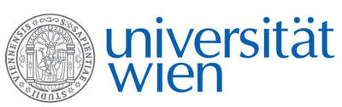 | Fakultät für Physik  Isotopenforschung und Kernphysik

E I N L A D U N G
zum

V E R A - S E M I N A R

von

Bernadett Weinzierl

Faculty of Physics – Aerosol Physics and Environmental Physics, University of Vienna

Global measurements of coarse mode aerosol – insights from recent aircraft field experiments

Although coarse-mode aerosol (>1 µm diameter), composed mainly of mineral dust and sea-salt, is highly abundant over large regions of the world, these particles form a particularly poorly understood and characterized subset of atmospheric aerosol constituents. Coarse mode aerosol is regularly transported over long distances. During long-range transport, particle properties may be modified thereby changing their associated impacts on the atmosphere and climate.
In this presentation, we will show results from airborne measurements of coarse mode aerosol with the German Aerospace Center (DLR) research aircraft Falcon and the NASA research aircraft DC8 during recent field experiments. We will discuss the modification of mineral dust during long-range transport as well as measurements of hemispheric differences in coarse mode aerosol distribution. The presentation closes with an outlook on high-priority research questions that future work and collaborations will aim to address.

Donnerstag, 15. Dezember 2016, 16:30 Uhr

1090 Wien, Währinger Str. 17, "Kavalierstrakt",
1. Stock, Victor-Franz-Hess-Hörsaal

R. Golser E.M. Wild

