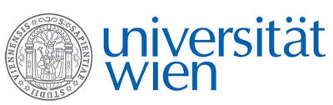 | Fakultät für Physik  Isotopenforschung und Kernphysik

E I N L A D U N G
zum

V E R A - S E M I N A R

von

Felix Höflmayer

Institute of Oriental and European Archaeology (OREA)
Austrian Academy of Sciences

“It is better to be vaguely right
than exactly wrong.” (C. Read)
Radiocarbon dating and Bronze Age chronologies in the eastern Mediterranean

Recent years have seen an increased interest and application of radiocarbon dating for absolute (calendrical) dating of Bronze Age chronologies of the eastern Mediterranean and ancient Near East. After intense debates about the date of the early Late Minoan Santorini eruption between a radiocarbon-backed high and an archaeological/historical low chronology, much more data for the historical chronology of Egypt, the relative archaeological sequences of the Levant, and, recently, the historical chronology of Mesopotamia has come to light. Currently, a dense network of consistent radiocarbon data around the eastern Mediterranean is emerging that challenges traditional chronologies. This talk summarizes the current state of radiocarbon chronologies in the eastern Mediterranean and ancient Near East and highlights new questions for the future.

Donnerstag, 12. Januar 2017, 16:30 Uhr

1090 Wien, Währinger Str. 17, "Kavalierstrakt",
1. Stock, Victor-Franz-Hess-Hörsaal

R. Golser E.M. Wild

