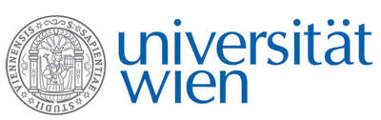 | Fakultät für Physik  Isotopenforschung und Kernphysik

E I N L A D U N G
zum

V E R A - S E M I N A R

von

Tobias Moreau

Fakultät für Physik – Isotopenforschung und Kernphysik
Universität Wien

Development and characterization of the
Ion Laser InterAction Setup (ILIAS)

The Ion Laser InterAction Setup ILIAS at the VERA-facility in Vienna is developed to explore laser photodetachment of negative ions in a gas-filled radio frequency quadrupole (RFQ) cooler. The aim of this project is a novel technique for element-selective negative ion beam purification in accelerator mass spectrometry (AMS). For this purpose, the ion cooler has to be suited to decelerate and cool intense atomic and molecular negative ion beams with keV energies.
In this talk I give an update on the current status and performance of the RFQ ion cooler. Recent experimental results will be discussed: This includes the suppression of a Cu¯ test beam by more than 99.999% by laser photodetachment, the suppression of MgO¯ vs. AlO¯ and comprehensive measurements of the ion residence time inside the RFQ ion cooler.

Donnerstag, 12. November 2015, 16:30 Uhr

1090 Wien, Währinger Str. 17, "Kavalierstrakt",
1. Stock, Victor-Franz-Hess-Hörsaal

R. Golser W. Kutschera E.M. Wild

