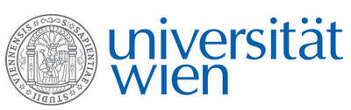 | Fakultät für Physik  Isotopenforschung und Kernphysik

E I N L A D U N G
zum

V E R A - S E M I N A R

von

Arnold Müller

Ion Beam Physics, ETH Zürich

Recent detector developments
for low energy AMS at ETH Zurich

In recent years great progress was achieved in building more and more compact AMS facilities for measuring radionuclides as ¹⁰Be, ¹⁴C, ²⁶Al, ¹²⁷I or actinides. Reducing system size is associated with lower beam energies, which makes the identification of single radionuclide ions challenging. Commonly the detection of radionuclides is performed by solid state detectors (Si pin diodes and silicon detectors) or by gas ionization chambers. In general solid state detectors offer a much easier handling compared with gas ionization chambers (GIC), but suffer radiation damage and are limited in resolution especially for heavy projectiles. In a ΔE-E_{res} configuration of the GIC particle identification can be performed. Substantial efforts have been made at ETH Zurich over the last years to better understand the physical processes contributing to the performance of GICs at low energies. In this context various detector designs were built and optimized for the application at small AMS systems. An overview on the latest findings and results related with these GICs will be given in this presentation.

Donnerstag, 15. Januar 2015, 16:30 Uhr

1090 Wien, Währinger Str. 17, "Kavalierstrakt",
1. Stock, Victor-Franz-Hess-Hörsaal

R. Golser W. Kutschera E.M. Wild

