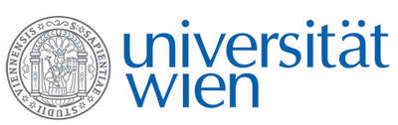 | Fakultät für Physik  Isotopenforschung und Kernphysik

E I N L A D U N G
zum

V E R A - S E M I N A R

von

Mihály Molnár

Hertelendi Laboratory of Environmental Studies
Institute of Nuclear Research, Hungarian Academy of Sciences
Debrecen, Hungary

MICADAS C-14 AMS applications
in environmental research in Hungary

Radiocarbon (C-14) analyses are applied in environmental protection, archaeology, geology, hydrology, climatology and other scientific branches in Hungary since the 1980’s. In 2011 a more modern AMS technology took over our old C-14 radiometric (GPC) method, which is based on isotope separation by accelerator mass spectrometry. AMS method requires much less sample quantity (0.1-100 mg) than the older GPS technique and gives ten times higher throughput.
For our laboratory a MICADAS type AMS system was developed by ETHZ (Zürich, Switzerland) in connection with environmental research, equipped with a gas inlet system to transfer CO₂ gas sample into the AMS ion source. Final acceptance of the EnvironMICADAS was completed at Debrecen, Hungary the autumn of 2011.
In the first three year of operation more than 8000 targets were analyzed in the new AMS lab of Hungary. Analytical performance, novel technical developments, interesting samples and results will be presented in this talk.

Donnerstag, 8. Januar 2015, 16:30 Uhr

1090 Wien, Währinger Str. 17, "Kavalierstrakt",
1. Stock, Victor-Franz-Hess-Hörsaal

R. Golser W. Kutschera E.M. Wild

