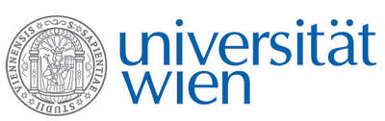 | Fakultät für Physik  Isotopenforschung und Kernphysik

E I N L A D U N G
zum

V E R A - S E M I N A R

von

Elisabetta Boaretto
Max Planck-Weizmann Institute Center for Integrative Archaeology and Anthropology
D-REAMS Radiocarbon Laboratory, Weizmann Institute of Science, Rehovot, Israel

Defining the Dating Assemblage for High Resolution Chronology: Wiggle Matching, Stratigraphy and Radiocarbon
for the Early Bronze Age

The establishment of an absolute chronology for the Late Bronze and Iron Age periods in the southern Levant would make it possible to use changes in material culture to provide invaluable information on trade, dissemination of know-how and the impact of climate on this fascinating period in history. For this a detailed absolute chronology is needed within individual sites and on a regional scale that has a resolution that can differentiate events within a century.
To achieve this challenging goal, only samples from well established primary contexts should be used. We define here a new concept called a “dating assemblage”. Such a dating assemblage is based on combining macroscopic with microscopic observations that identify an assemblage of associated materials that include the datable material. This information is ideally obtained on-site during the excavation. Chronological studies at Megiddo demonstrate that with this approach high resolution dating can be achieved, with very few outliers present in the data sets.

Donnerstag, 06. November 2014, 16:30 Uhr

1090 Wien, Währinger Str. 17, "Kavalierstrakt",
1. Stock, Victor-Franz-Hess-Hörsaal

R. Golser W. Kutschera E.M. Wild

