
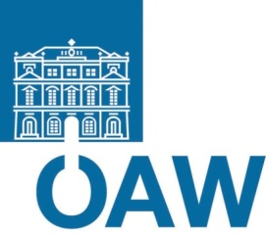


Fakultät für Physik

Isotopenforschung und Kernphysik
Stefan-Meyer-Institut
für subatomare Physik

E I N L A D U N G
zum gemeinsamen

V E R A – S M I – S E M I N A R

von

Jochen Schieck

Institute of High Energy Physics
Austrian Academy of Sciences, Vienna

Darkness beyond the Standard Model

With the discovery of the Higgs Boson all particles of the Standard Model of Particle Physics are experimentally identified. However, we know that the Standard Model can not explain all measurements. In particular several astrophysical measurements can not be explained within the Standard Model. A famous shortcoming is the existence of the so-called Dark Matter. A very well motivated candidate for the Dark Matter are WIMPs, weakly interactive massive particles. The current status of WIMP searches and the plans of the new experimental group at the Institute of High Energy Physics are presented.

Donnerstag, 23. Jänner 2014, 16:30 Uhr
1090 Wien, Währinger Str. 17, "Kavalierstrakt",
1. Stock, Victor-Franz-Hess Hörsaal

R. Golser W. Kutschera E.M. Wild

E. Widmann

