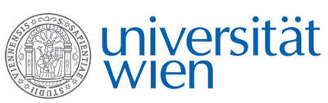
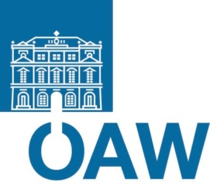


Fakultät für Physik

Isotopenforschung und Kernphysik
Stefan-Meyer-Institut
für subatomare Physik

E I N L A D U N G
zum gemeinsamen

V E R A – SMI - S E M I N A R

von

Oliver Forstner^{1,2} for the IS541 Collaboration³

¹ VERA Laboratory, Faculty of Physics, University of Vienna, Austria
² Stefan-Meyer-Institute of the Austrian Academy of Sciences, Austria
³ CERN, Geneva, Switzerland

Quasi-free neutron decay of the halo nucleus ¹¹Be

The Q-value of the beta-minus decay from ¹¹Be to ¹¹B is 11.509 MeV, which is above the binding energy of a proton in ¹¹B. Therefore the one-neutron halo nucleus ¹¹Be can emit a proton in the beta decay of the halo neutron. However, due to the Q-value of this decay channel (280.7±0.3 keV) the expected branching ratio will be very low – most estimates are a few times 10⁻⁸ – and the detection of the outgoing proton with a kinetic energy of a few hundred keV is challenging. Therefore a new approach was pursued detecting the remaining nucleus ¹⁰Be with the help of accelerator mass spectrometry (AMS). To study this rare decay a beam of ¹¹Be ions was produced at the radioactive ion beam facility ISOLDE at CERN and implanted in a copper collection sample. The sample was transferred to the VERA AMS facility at the University of Vienna where the ¹⁰Be content was determined through a ¹⁰Be/⁹Be ratio measurement.
After an introduction into the physics of halo nuclei I will present experimental details of the collection at ISOLDE and the AMS measurement at VERA as well as results of the successful detection of this rare decay channel.

Donnerstag, 16. Jänner 2014, 16:30 Uhr
Stefan-Meyer-Institut für subatomare Physik
1090 Wien, Boltzmanngasse 3, 2. Stock, Seminarraum 2.08

R. Golser W. Kutschera E.M. Wild

E. Widmann

