
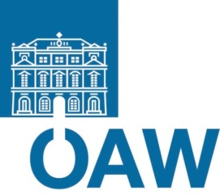


Fakultät für Physik

Isotopenforschung und Kernphysik
Stefan-Meyer-Institut
für subatomare Physik

E I N L A D U N G
zum gemeinsamen

V E R A – SMI - S E M I N A R

von

Klaus Blaum

Max-Planck-Institut für Kernphysik, Heidelberg

Fundamental tests of nature with
cooled and stored exotic ions

The presentation will concentrate on recent applications with exciting results of Penning traps in atomic and nuclear physics with cooled and stored exotic ions. These are high-accuracy mass measurements of short-lived radionuclides, g-factor determinations of the bound-electron in highly-charged, hydrogen-like ions and
g-factor measurements of the proton and antiproton. The experiments are dedicated, e.g., to astrophysics studies and to tests of fundamental symmetries in the case of mass measurements on radionuclides, and to the determination of fundamental constants and a CPT test in the case of the g-factor measurements.

Donnerstag, 09. Jänner 2014, 16:30 Uhr
1090 Wien, Währinger Str. 17, "Kavalierstrakt",
1. Stock, Victor-Franz-Hess Hörsaal

R. Golser W. Kutschera E.M. Wild

E. Widmann

