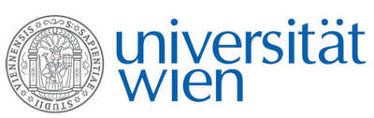 | Fakultät für Physik  Isotopenforschung und Kernphysik

E I N L A D U N G
zum

V E R A - S E M I N A R

von

Thomas Prohaska

University of Natural Resources and Life Sciences (BOKU),
University Research Center Tulln, Department of Chemistry – VIRIS laboratory

Guidepost Strontium: Isotope research in
Analytical Ecogeochemistry

Recent developments of analytical techniques for isotope ratio measurements allow the access to new scientific insights in transdisciplinary research areas. In this lecture, the use of inductively coupled plasma mass spectrometry will be presented as one high-performance analytical method in isotope research. Selected applications in ecogeochemistry with a special focus on the Sr isotopic system will be presented making use of the natural variation as well as using isotopic spikes to monitor natural processes.

Donnerstag, 17.01.2013 16:30 Uhr

1090 Wien, Währinger Str. 17, "Kavalierstrakt",
1. Stock, Victor-Franz-Hess Hörsaal

R. Golser W. Kutschera E.M. Wild

