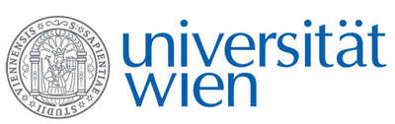 | Fakultät für Physik  Isotopenforschung und Kernphysik

E I N L A D U N G
zum

V E R A - S E M I N A R

von

Jenny Feige

University of Vienna, Faculty of Physics – Isotope Research

Deep-Sea Astronomy: Searching for Signals of Recent Nucleosynthesis in the Local Universe with AMS

Stars with masses larger than 8 Msun end their life in a supernova (SN) explosion. The nuclides, which are created in the late burning phases of such stars and also during the explosion are ejected and entrained in the SN-shell. This material expands rapidly into the surrounding interstellar medium. Such events happened in the recent history in our solar neighborhood and led to the formation of the Local Bubble, characterized as a hot void embedding our solar system.
Minute traces of close-by SN ejects might be found in terrestrial archives and can potentially be detected by accelerator mass spectrometry (AMS). I will report on the search for SN-ejected long-lived radionuclides in two deep-sea sediment cores from the Indian Ocean.

Donnerstag, 25. Oktober 2012, 16:30 Uhr

1090 Wien, Währinger Str. 17, "Kavalierstrakt",
1. Stock, Victor-Franz-Hess Hörsaal

R. Golser W. Kutschera E.M. Wild

