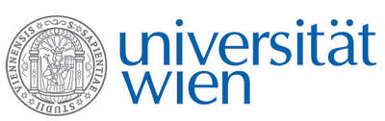 | Fakultät für Physik  Isotopenforschung und Kernphysik

E I N L A D U N G
zum

V E R A - S E M I N A R

von

Gianluca Quarta

CEDAD (Centre for Dating and Diagnostic), Department of Engineering of Innovation, University of Salento, Italy

Accelerator Mass Spectrometry and Ion Beam Analysis as complementary tools in Cultural Heritage diagnostics at CEDAD

Among the analytical methods based on the use of ion beams with energies in the MeV range, those with a higher potential in cultural heritage diagnostics are surely IBA (Ion Beam Analysis) techniques and radiocarbon dating by AMS (Accelerator Mass Spectrometry). Taking advantages of the presence at the accelerator facility of the University of Salento (CEDAD) of experimental lines for ¹⁴C AMS dating and PIXE-PIGE non-destructive analyses in external beam mode, different studies have been carried out by combining these methods for the study of the same archaeometric problem.
After a review of the experimental beam lines available at CEDAD and a description of the ongoing projects, different case studies will be presented and discussed such as the ¹⁴C dating and compositional analyses of the inner cores of the Riace Bronzes, the determination of the provenance of obsidians tools from ¹⁴C dated Neolithic sites in the Mediterranean and the study of the diagenetic state of cremated bones submitted to ¹⁴C dating.

Donnerstag, 13. Oktober 2011, 16:30 Uhr

1090 Wien, Währinger Str. 17, "Kavalierstrakt",
1. Stock, Victor-Franz-Hess Hörsaal

R. Golser W. Kutschera E.M. Wild

