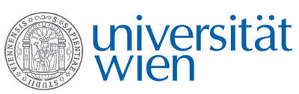 | Fakultät für Physik  Isotopenforschung und Kernphysik
E I N L A D U N G
zum

V E R A - S E M I N A R

von

Lutz Nasdala

Institute of Mineralogy and Crystallography, University of Vienna

Ion irradiation:
A tool to study radiation damage in minerals

The impact of radioactivity (in particular recoils of heavy daughter nuclei upon emission of an alpha particle) may cause severe changes and damages to crystalline minerals, up to their complete amorphisation. Heavy-ion irradiation is used to investigate and quantify irradiation effects in orthosilicates and -phosphates. A new approach is discussed in the talk, namely, the irradiation of thin FIB foils whose thicknesses correspond to the penetration depth of the ions irradiated. Finally, examples are presented for how MeV helium irradiation is applied to study the so-called alpha haloes in rock-forming minerals.

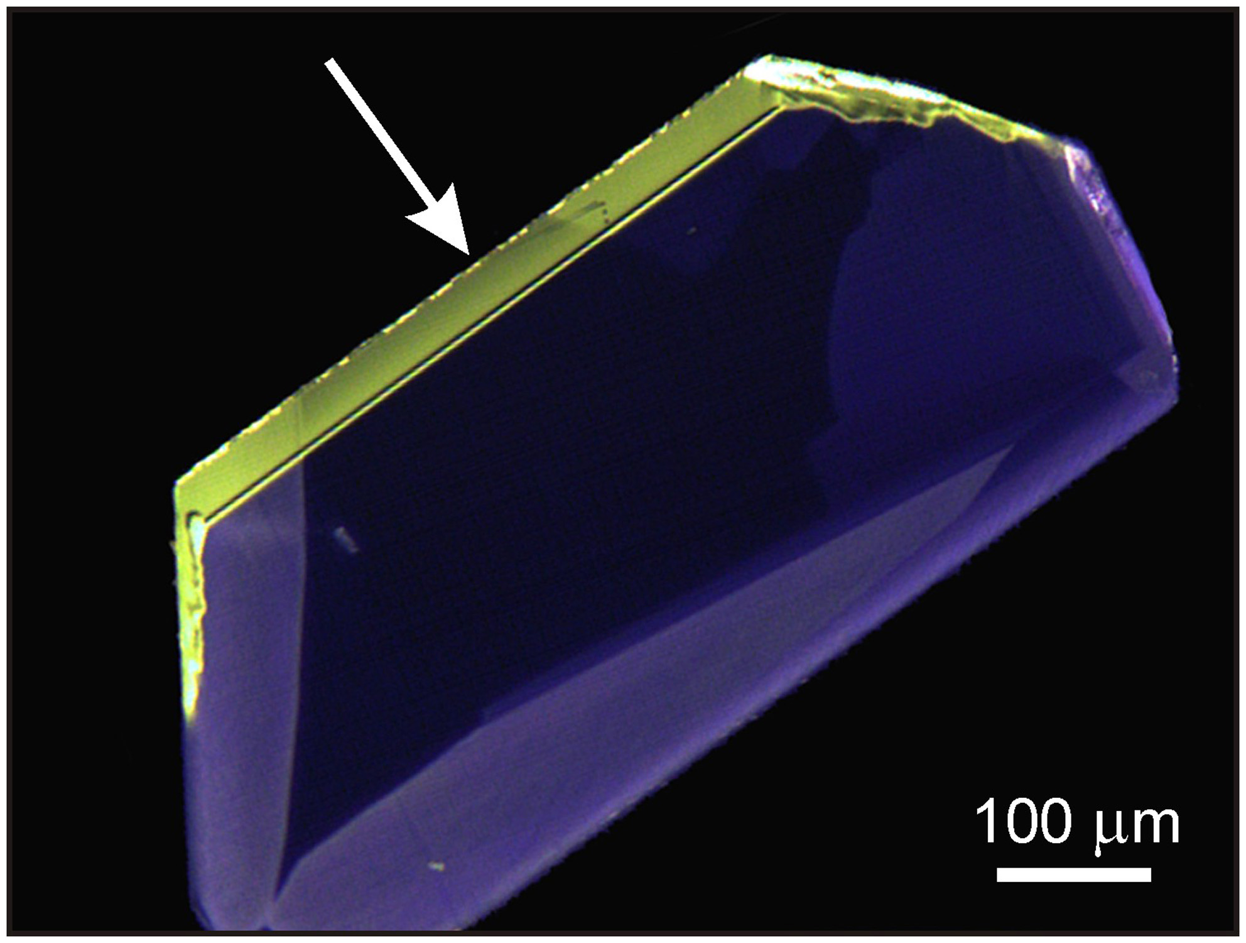
Cathodoluminescence image of a synthetic zircon (ZrSiO₄) after irradiation with 8.8 MeV helium ions (the irradiation direction is marked with an arrow). The ca. 33 micrometres thick irradiated volume shows intense yellow defect emission.

Donnerstag, 12. Januar 2012, 16:30 Uhr

1090 Wien, Währinger Str. 17, "Kavalierstrakt",
1. Stock, Victor-Franz-Hess Hörsaal

R. Golser W. Kutschera E.M. Wild

