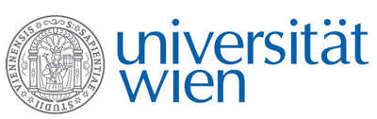 | Fakultät für Physik  Isotopenforschung und Kernphysik

E I N L A D U N G
zum

V E R A - S E M I N A R

von

Ingeborg Levin

Institut für Umweltphysik, Universität Heidelberg

The global atmospheric carbon cycle and its recent changes – insights from Radiocarbon observations

Atmospheric CO₂ observations provide key information to our understanding of the global carbon cycle and its recent perturbations. These data revealed that the atmospheric burden of CO₂ has increased by more than 30% in the last century due to emissions from fossil fuel burning and land use change, with strong implications on the earth radiation balance. Currently, about half of these annual emissions are taken up by oceans and land; however, the exact share between sinks and their future capacity are subject to an ongoing debate. The current state of our knowledge on recent carbon fluxes will be presented and the use of long-term Radiocarbon observations to disentangle the different source/sink contribution will be discussed.

Donnerstag, 10. November 2011, 16:30 Uhr

1090 Wien, Währinger Str. 17, "Kavalierstrakt",
1. Stock, Victor-Franz-Hess Hörsaal

R. Golser W. Kutschera E.M. Wild

