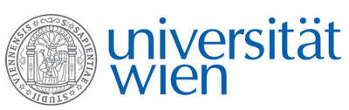 | Fakultät für Physik  Isotopenforschung und Kernphysik

E I N L A D U N G
zum

V E R A - S E M I N A R

von

Umesh Garg

University of Notre Dame, Indiana, USA, and GSI Darmstadt, Germany

Nuclear Incompressibility, the Asymmetry Term,
and the MEM Effect

The Nuclear Incompressibility parameter is one of three important components characterizing the nuclear equation of state. It has crucial bearing on diverse nuclear and astrophysical phenomena, including radii of neutron stars, strength of supernova collapse, emission of neutrinos in supernova explosions, and collective flow in medium- and
high-energy nuclear collisions.
In this talk I will review current status of the research on direct experimental determination of nuclear incompressibility via the compressional-mode giant resonances. In particular, recent measurements on a series of Sn and Cd isotopes have provided an "experimental" value for the asymmetry term of nuclear incompressibility. We also find that the GMR centroid energies of the in both Sn and Cd isotopes are significantly lower than the theoretical predictions, pointing to the role of superfluidity and the MEM (Mutual Enhancement of Magicity) effect.

Donnerstag, 03. November 2011, 16:30 Uhr

1090 Wien, Währinger Str. 17, "Kavalierstrakt",
1. Stock, Victor-Franz-Hess Hörsaal

R. Golser W. Kutschera E.M. Wild

