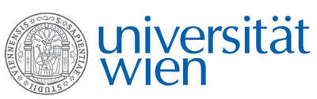 | Fakultät für Physik  Isotopenforschung und Kernphysik

E I N L A D U N G
zum

V E R A - S E M I N A R

von

Pontus ANDERSSON

Physics Department, University of Gothenburg, Sweden,
and VERA Laboratory, Fakultät für Physik, Universität Wien

Laser Photodetachment of Negative Ions: Fundamental Research and Applications
in Mass Spectrometry

The Department of Physics at the University of Gothenburg perform measurements of the fundamental structural and dynamic properties of negative ions, such as measurements of electron affinities and the excitation energies and lifetimes of excited states. The main method for these measurements is laser photodetachment threshold spectroscopy in a collinear geometry. Both the fundamental research, and the possible applications of these measurements in a mass spectrometric context are presented in this talk.
As an example of the fundamental studies, a recent measurement of a previously unobserved, but theoretically predicted, excited state in the negative atomic Platinum ion is presented.
Further is a method of measuring the lifetimes of metastable excited states in atomic negative ions, using laser photodetachment and an ion storage ring explained.
One example of the applications of the negative ion research is given by the measurement of the depletion efficiency of Cobalt in a Nickel negative ion beam, using a combination of a gas filled Radio Frequency Quadrupole and a collinear applied laser beam.
The intended projects as a postdoc here at VERA are also presented.

Donnerstag, 07. Oktober 2010, 16:30 Uhr

1090 Wien, Währinger Str. 17, "Kavalierstrakt",
1. Stock, Seminarraum von VERA

R. Golser W. Kutschera E.M. Wild

