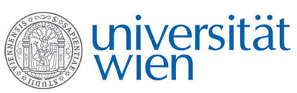 | Fakultät für Physik  Isotopenforschung und Kernphysik

E I N L A D U N G
zum

V E R A - S E M I N A R

von

Jakob Yngvason

Fakultät für Physik – Mathematische Physik, Universität Wien

Bose-Einstein condensation and quantized vortices

One of the most fascinating phenomena in the physics of cold quantum gases is the appearance of vortices in rotating systems. Such vortices are a manifestation of superfluidity and their experimental and theoretical study gives rise to many challenging problems. In the seminar a pedestrian view on Bose-Einstein condensation and the formation of vortices from the theoretical side will be presented.

Donnerstag, 12. November 2009, 16:30 Uhr

1090 Wien, Währinger Str. 17, "Kavalierstrakt",
1. Stock, Victor-Franz-Hess-Hörsaal

R. Golser W. Kutschera E.M. Wild

