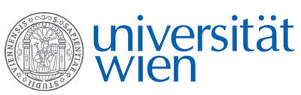 | Fakultät für Physik  Isotopenforschung und Kernphysik

E I N L A D U N G
zum

V E R A - S E M I N A R

von

Irka Hajdas

Ion Beam Physics, ETH Zürich

Radiocarbon chronologies
of lake sediments - an overview

Among continental archives lake sediments are nearly the most studied records of past environmental changes. Certainly it is the wealth of proxy (sedimentary information, tephra, pollen, stable isotopes, macrofossils, geochemistry, palaeomagnetic, charcoal etc.) that can be recovered from lake deposits that places them on top of the list. On the other hand there are other natural archives such as ice cores or tree rings that are considered to be superb because of resolution and precise chronological time control.

After 20 years of applying ¹⁴C dating to building time scales of various lakes around the globe I am still confident that lake sediments are the most valuable material to study. The great advantage of lakes is that they are quite common and distributed around the globe. The global nature of ¹⁴C allows correlation and synchronisation. Moreover, new possibilities and developments in AMS ¹⁴C dating increase chances for obtaining reliable chronologies of those records.
I will present an overview of studies and discuss various problems (such as hard water effect) occurring in those records.

Donnerstag, 28. Januar 2010, 16:30 Uhr

1090 Wien, Währinger Str. 17, "Kavalierstrakt",
1. Stock, Victor-Franz-Hess-Hörsaal

R. Golser W. Kutschera E.M. Wild

