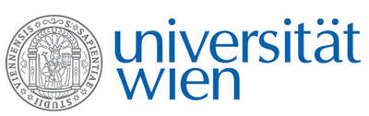 | Fakultät für Physik  Isotopenforschung und Kernphysik

E I N L A D U N G
zum

V E R A - S E M I N A R

von

Amnon MARINOV

Racah Institute of Physics, Hebrew University of Jerusalem

Super- and Hyperdeformed Isomeric States and Long-lived Superheavy Elements
Long-lived high spin isomeric states have been found in recent years in the second minimum (the superdeformed minimum) and in the third minimum (the hyperdeformed minimum) of the potential energy of nuclei when displayed as a function of deformations. Their existence enabled us to consistently interpret the previously observed evidence for the production of element 112 via secondary reactions, and to propose coherent descriptions for heretofore unexplained radioactive decays seen in natural materials. Based on these results accurate mass measurements were performed on natural Th and Au substances. Evidence for long-lived isomeric states has been obtained in neutron-deficient 211, 213, 217 and 218Th nuclei, in atomic masses 261 and 265, most probably due to the superheavy isotopes ²⁶¹Rg and ²⁶⁵Rg (element 111), and in the superactinide region, in a nucleus with mass number 292 and Z=~122.

Donnerstag, 11. Dezember 2008, 16:30 Uhr

1090 Wien, Währinger Str. 17, "Kavalierstrakt",
1. Stock, Seminarraum von VERA

R. Golser W. Kutschera

