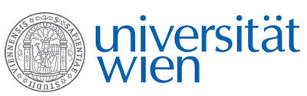 | Fakultät für Physik  Isotopenforschung und Kernphysik

E I N L A D U N G
zum

V E R A - S E M I N A R

von

Heinz Hugo LOOSLI

Physikalisches Institut der Universität Bern

New Ar-39 measurements in granite samples
from Hiroshima and Nagasaki

Risk factors for cancer after an irradiation are mainly derived from Survivers in Hiroshima and Nagasaki.
However, fluxes of fast neutrons, which contribute a considerable part to the dosis, are in Hiroshima only measured to a limited distance (and even with large errors), and for Nagasaki only calculations are available.
By Ar-39 from the ³⁹K(n,p) reaction new (precise) data could be determined in Hiroshima and for the first time in Nagasaki. The results are presented in the talk and their influence for irradiation protection is discussed.
A main topic is the presentation of new measurements of cross sections of the ³⁹K(n,p)³⁹Ar reaction as a function of energy, gained in irradiation experiments, done by a group around Werner Rühm, München.

Donnerstag, 18. Dezember 2008, 16:30 Uhr

1090 Wien, Währinger Str. 17, "Kavalierstrakt",
1. Stock, Seminarraum von VERA

R. Golser W. Kutschera

