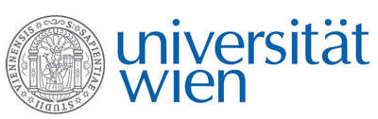 | Fakultät für Physik  Isotopenphysik

I N V I T A T I O N
for a

V E R A - S E M I N A R

with

Judith Reindl
Institut für angewandte Physik und Messtechnik, Fakultät für Luft- und Raumfahrttechnik, Universität der Bundeswehr München, Germany

From Micrometer to Milimeter Scale -
The Application of Ions in Radiobiology and Radiation Medicine

Human cells are constantly exposed to ionizing radiation of different quality, which can cause severe damage in the genome, leading to cell death or cancer formation. Especially new types of radiotherapy using ions, and the planning of manned missions into deep space create the need to understand the effects of particle radiation to eucaryotic cells and organisms.
It is well known that particle radiation with a high linear energy transfer (LET) (>10keV/µm) shows an enhanced biological effect compared to low-LET radiation, such as photons. Furthermore, using accelerator-based facilities it is possible to investigate new therapy approaches such as particle minibeam radiotherapy (pMBT).
This talk focuses on the techniques and studies in radiobiological and medical research to be performed on accelerators, helping understand the effect of radiation and develop new therapy techniques.

Thursday, 25.04.2024, 16:30 o'clock

1090 Wien, Währinger Str. 17, "Kavalierstrakt",
1. Stock, Victor-Franz-Hess Hörsaal

R. Golser K. Hain W. Kutschera

