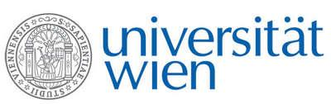 | Fakultät für Physik  Isotopenphysik

I N V I T A T I O N

for a

V E R A – S E M I N A R

with

Saverio Bartalini

Istituto Nazionale di Ottica - INO-CNR, Firenze, Italy
and
ppqSense S.R.L., Sesto Fiorentino, Italy

Laser-based detection of ¹⁴CO₂ at ppq level

Combining state-of-the art spectroscopy techniques with semiconductor Quantum cascade lasers-QCLs allows to get ideal metrological probes to measure extremely low concentrations of rare molecules. The best results have been obtained in the last few years with saturated-absorption cavity ring-down (SCAR), a nonlinear cavity ring-down technique, to detect the very elusive ¹⁴CO₂ molecule. The sensitivity achieved by SCAR, of a few parts in 10¹⁵, provides a wide dynamic range for radiocarbon detection, from sub-pMC (percent Modern Carbon) level to thousand times “modern” enrichment. The intrinsic compactness, transportability and ease of operation of such a laser-based technique, are disclosing a number of new applications, some already demonstrated, some coming soon. They encompass bio vs. fossil based materials and fuels concentration determination, atmospheric analysis of ¹⁴C/¹²C ratio for climate change assessment, biomedical and pharmacological measurements for ¹⁴C labeled compounds and precise radiocarbon measurement in radioactive waste. The new scenarios opened by high-performing SCAR spectroscopy will be discussed.

Thursday, 16. March 2023, 16:30 o‘clock

1090 Wien, Währinger Str. 17, "Kavalierstrakt",
1. Stock, Victor-Franz-Hess Hörsaal

R. Golser M. Martschini W. Kutschera

