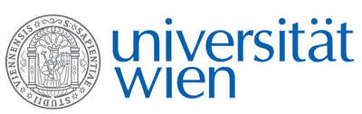 | Fakultät für Physik  Isotopenphysik  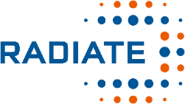

I N V I T A T I O N
for a

V E R A - S E M I N A R

with

Stephan Winkler

Helmholtz-Zentrum Dresden-Rossendorf

The iThemba LABS AMS system and AMS applications in southern Africa

The iThemba Laboratory for Accelerator Based Science (iThemba LABS) accelerator mass spectrometry (AMS) system, situated in Johannesburg (South Africa) on a sub-campus of the wider WITS University Campus, was opened in July 2014, after the installation of the high-energy side beam-line. The system was implemented in several stages starting in 2005 with the refurbishment of the 6 Megavolt linear tandem accelerator (HVEE EN Model), the construction of an ion-source and AMS injector beam-line, with the final elements – a modern AMS analysing beam-line supplied by NEC – installed in 2014.
AMS is a technique used mostly to measure long-lived radioisotopes in the environment, most prominently amongst them ¹⁴C (“radiocarbon”), ¹⁰Be, and ²⁶Al. These isotopes have a wide and increasing range of applications, e.g. in heritage studies, environmental sciences and ecology, geology, to name but a few. It has to be emphasized that despite rich opportunities for such studies all over Africa, iThemba LABS host the first, and currently only, AMS system on the African continent, compared to more than 100 such facilities world-wide.
I will show the Journey of implementing AMS measurements at this unique system, and give an overview of the first completed and on-going projects.

Tuesday, 26 April 2022, 16:30 o'clock

1090 Wien, Währinger Str. 17, "Kavalierstrakt",
1. Stock, Victor-Franz-Hess Hörsaal

R. Golser W. Kutschera

