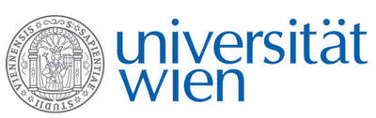 | Fakultät für Physik  Isotopenphysik  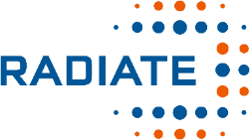

I N V I T A T I O N
for a

V E R A - S E M I N A R

with

Jixin QIAO

Department of Environmental and Resource Engineering,
Technical University of Denmark (DTU), Roskilde, Denmark

Modern accelerator mass spectrometry
facilitates environmental tracer studies using ultra-trace radioisotopes: An example of anthropogenic U-233 and U-236

With the continuous development of modern accelerator mass spectrometry (AMS) in the past decade, detection of many ultra-trace levels of radioisotopes in the environment became possible. This provides vast opportunities for scientists to explore them as environmental tracers to study the natural processes such as ocean circulation, sedimentation, etc., and the impact of human activities, such as nuclear safety, pollutant/nutrient transport, etc.
Since 2013, a collaborative work between VERA and DTU was initiated to explore the power of AMS in ultra-trace-level radioisotopes determination and related environmental tracer studies, specifically the minor uranium isotopes U-236 and lately U-233. Here, a series of studies on anthropogenic U-233 and U-236 in the Baltic Sea, the Pacific Ocean and the Arctic Ocean are presented to demonstrate the promises of this tracer pair in identifying radioactive source terms, reconstructing historical nuclear activities, benchmarking age-depth models in sediment chronology, tracking ocean circulation pathways and transit times, quantifying water mass composition and estimating pollutant/nutrient dynamics.

Thursday, 30. June 2022, 16:30 o'clock

1090 Wien, Währinger Str. 17, "Kavalierstrakt",
1. Stock, Victor-Franz-Hess Hörsaal

R. Golser K. Hain W. Kutschera

