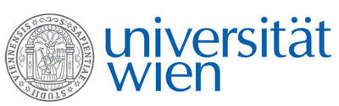 | Fakultät für Physik  Isotopenphysik
I N V I T A T I O N
for a

V E R A - S E M I N A R

with

Irka Hajdas

Laboratory for Ion Beam Physics, ETH Zurich, Switzerland

Bomb peak ¹⁴C and the proposal for a new Anthropocene epoch

The unprecedented environmental changes resulting from anthropogenic activities initiated during the Great Acceleration of the mid-20th century can be traced with the help of ¹⁴C analysis. In the early 1950s, the decreasing trend observed in ¹⁴C concentration of the atmosphere (Suess effect) has been temporarily reversed by thermonuclear tests of the 1950/60s, which created an excess of artificially produced ¹⁴C (Bomb pulse). This time marker of the mid-20th century is a useful tool in numerous applications in environmental, biomedical and forensic studies. Recently, the detection of the bomb peak in natural archives has also been proposed as a tool to locate and date the onset of a new epoch the Anthropocene. The Anthropocene Working Group (AWG) supervises research of stratigraphic successions at 12 sites around the globe in order to facilitate a formal submission to the Subcommission on Quaternary Stratigraphy [1]. This lecture will present an overview of the role the ¹⁴C bomb peak and its onset plays in the research dedicated to establishing the Global Boundary Stratotype Section and Point (GSSP) for the proposed Anthropocene.
[1] P. Voosen, Bids for Anthropocen’s ‘golden spike’ emerge, Science 376 (6593),
06 May 2022, 562-563.

Tuesday, 24 May 2022, 17:30 o'clock

1090 Wien, Währinger Str. 17, "Kavalierstrakt",
1. Stock, Victor-Franz-Hess Hörsaal

R. Golser W. Kutschera

