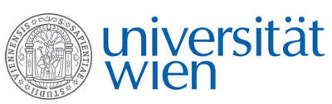 | Fakultät für Physik  Isotopenphysik

E I N L A D U N G
zum

V E R A - S E M I N A R

von

Michael KERN, Oscar MARCHHART,
Johanna PITTERS, Alexander WIESER

Faculty of Physics – Isotope Physics, Vienna Environmental Research Accelerator (VERA), University of Vienna

Presentations from the Spring Meeting of the German Physical Society, Hannover, 8-13 March 2020

M. Kern et al.: Increased ionization efficiency for the detection of ²³⁶U
and ²³³U by AMS
O. Marchhart et al.: AMS of ⁹⁰Sr at the sub-fg-level using laser photo-
detachment at VERA
J. Pitters et al.: Ultra-trace detection of ⁹⁹Tc in environmental samples
by AMS
A. Wieser et al.: Developments towards the detection of ¹³⁵Cs and ¹³⁷Cs
by AMS

Donnerstag, 19. März 2020, 16:30 Uhr

1090 Wien, Währinger Str. 17, "Kavalierstrakt",
1. Stock, Victor-Franz-Hess Hörsaal

R. Golser W. Kutschera E.M. Wild

