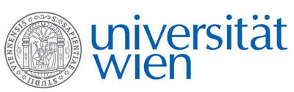 | Fakultät für Physik  Isotopenforschung und Kernphysik

E I N L A D U N G
zum

V E R A - S E M I N A R

von

Barbara Katharina Geist

Division of Nuclear Medicine, Medical University of Vienna

Physics meets Medicine:
Quantification in Nuclear Medicine

Positron Emission Tomography (PET) is a functional imaging method in Nuclear Medicine. Here, biomolecules labeled with positron-emitting radioisotopes are employed as non-invasive probes (tracers). With dynamic scans of a combined PET and Magnetic Resonance tool (PET/MR), tracer concentrations can be measured over time with very high morphological resolution.
The fate of a tracer in a certain organ and its sub-regions is dependent on underlying biochemical processes, which can be described with kinetic models. The development of a kinetic model is accompanied by experiments, i.e. animal and human studies, leading to a deeper understanding of these processes and to an improved diagnosis. An example for the derivation of such a model is the investigation of kidney function using ¹⁸F-labeled glucose (FDG). This and further developments are being conducted at the Division of Nuclear Medicine at the Medical University of Vienna, which will be presented during this talk.

Donnerstag, 22. März 2018, 16:30 Uhr

1090 Wien, Währinger Str. 17, "Kavalierstrakt",
1. Stock, Victor-Franz-Hess Hörsaal

R. Golser W. Kutschera E.M. Wild

