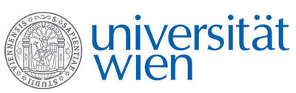 | Fakultät für Physik  Isotopenforschung und Kernphysik

E I N L A D U N G
zum

V E R A - S E M I N A R

von

Clemens Walther

Leibnitz Universität Hannover, Institut für Radioökologie und
Strahlenschutz

Resonant Laser-SNMS on actinides
for spatially resolved ultra-trace analysis

Transport mechanisms of actinides in natural systems are of major relevance to evaluate their distribution in geological formations at contaminated areas and storage sites. The new resonant Laser-SNMS (Secondary Neutral Mass Spectrometry) system at the IRS Hannover was developed to cover these specifications by combining the high element selectivity of resonance ionization with the non-destructive analysis of a static TOF-SIMS with spatial resolution down to 70 nm. First mass spectra of synthetical uranium, plutonium technetium and strontium samples demonstrated the expected suppression of interfering elements and molecules. In MOX fuel ²³⁸Pu and ²³⁸U were successfully discriminated. Due to the very low sample consumption isotope selective images of environmental sample material is performed almost non-invasively. Examples include natural minerals from Afghanistan close to Kabul containing enhanced levels of natural radioactivity, particles from the Chernobyl exclusion zone and from the evacuated zone close to the Fukushima Daichii nuclear power plant.

Donnerstag, 2. März 2017, 16:30 Uhr

1090 Wien, Währinger Str. 17, "Kavalierstrakt",
1. Stock, Victor-Franz-Hess-Hörsaal

R. Golser E.M. Wild

