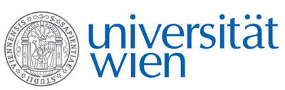 | Fakultät für Physik  Isotopenforschung und Kernphysik

E I N L A D U N G
zum

V E R A - S E M I N A R

von

Ernst Pernicka

Institute for Geosciences, University of Heidelberg
and
Curt Engelhorn Centre for Archaeometry, Mannheim

Authentic and fake gold: Analytical investigations
of archaeological gold finds

Gold was valued highly in all cultures and all periods and the associated symbolisms are also very similar. Its practical value, however, is rather low. Accordingly, gold was mainly used for ritual objects and as medium for exchange (coinage) since the sixth century BC. Today antiquities made of gold are much sought after and achieve high prices in auctions. This attracts forgers and often requires investigations with methods of material science. But sometimes forgers are not mainly motivated by financial gain but also by ideology or rise in public recognition. The find of an assemblage of fake Late Bronze Age gold items at Bernstorf in Bavaria may serve as an example that even resulted in the foundation of a museum. The lecture will provide an overview of the possibilities and limitations to identify fake archaeological gold objects with analytical methods and will describe case studies.

Donnerstag, 04.05.2017, 16:30 Uhr

1090 Wien, Währinger Str. 17, "Kavalierstrakt",
1. Stock, Victor-Franz-Hess-Hörsaal

R. Golser W. Kutschera E.M. Wild

