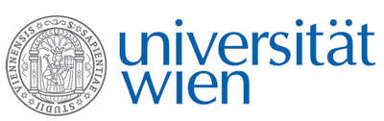 | Fakultät für Physik  Isotopenforschung und Kernphysik

E I N L A D U N G
zum

V E R A - S E M I N A R

von

Oliver Heckl

Fakultätszentrum für Nanostrukturforschung
Fakultät für Physik, Universität Wien

Recent Advancements in Mid-Infrared Optical Frequency Comb Sources and Spectroscopy

Optical frequency comb spectroscopy has blossomed into a versatile tool for the broad-bandwidth and high-spectral-resolution study of molecules in the visible and near-infrared. Cavity-Enhanced Direct Frequency Comb Spectroscopy (CE-DFCS) enables measurements with a simultaneous bandwidth of up to hundreds of nm at a frequency resolution comparable to stable CW light sources.
During this talk I will present recent developments of mid-IR frequency comb sources and the application of frequency comb sources for mid-IR spectroscopy. Topics include work on direct frequency comb measurements of OD + CO → DOCO kinetics, continuous probing of cold complex molecules with infrared frequency comb spectroscopy as well as work on cavity ring down spectroscopy for mid-IR mirror characterization.

Donnerstag, 16.03.2017, 16:30 Uhr

1090 Wien, Währinger Str. 17, "Kavalierstrakt",
1. Stock, Victor-Franz-Hess-Hörsaal

R. Golser W. Kutschera E.M. Wild

