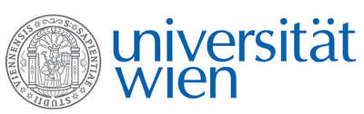 | Fakultät für Physik  Isotopenforschung und Kernphysik

E I N L A D U N G
zum

V E R A - S E M I N A R

von

Jürg Beer

Eawag, Swiss Federal Institute of Aquatic Science and Technology
Dübendorf, Switzerland

What’s New ‘Under the Sun?’

It is generally accepted that the Sun is the ultimate source of energy. It keeps us alive and drives the climate system. But the Sun is also a variable star. It is still not clear what role its variability plays in climate change and to what extent it poses a threat to mankind.
Systematic observation of the Sun commenced with the invention of the telescope about 400 years ago. Modern instruments provide practically unlimited information on almost every aspect of the Sun for the past few decades. But the Sun has a history of more than 4 billion years.
One way out of this problem and to learn more about the long-term behaviour of the Sun is to rely on indirect information which is stored in natural archives such as ice and sediment cores, tree rings etc. Accelerator mass spectrometry provided the key and became a new ‘telescope’ to read this information with an unprecedented sensitivity. It opened up a window to look back on some aspects of solar variability for thousands of years.
In the talk it will be discussed how the information is retrieved, what we have learned so far, and what could be done in the future.

Donnerstag, 14.04.2016, 16:30 Uhr

1090 Wien, Währinger Str. 17, "Kavalierstrakt",
1. Stock, Victor-Franz-Hess-Hörsaal

R. Golser W. Kutschera E.M. Wild

