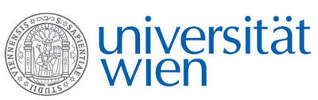 | Fakultät für Physik  Isotopenforschung und Kernphysik

E I N L A D U N G
zum

V E R A - S E M I N A R

von

Walter Kutschera

Fakultät für Physik – Isotopenforschung und Kernphysik
Universität Wien

Report on the
Gordon Research Conference on Nuclear Chemistry, New London, NH, USA, 1-5 June 2015

After a brief review of the status of nuclear structure studies, some new applications of nuclear physics will be discussed. These will include the situation of the ^{99m}Tc production, the use of layered nanoparticle for targeted alpha generator radiotherapy, and ⁸¹Kr measurements with the laser atom-trap technique to date old groundwater.

Donnerstag, 11. Juni 2015, 16:30 Uhr

1090 Wien, Währinger Str. 17, "Kavalierstrakt",
1. Stock, Victor-Franz-Hess-Hörsaal

R. Golser W. Kutschera E.M. Wild

