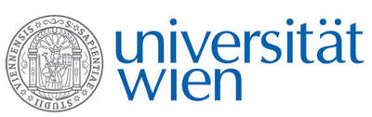 | Fakultät für Physik  Isotopenforschung und Kernphysik

E I N L A D U N G
zum

V E R A - S E M I N A R

von

David Fink

Institute for Environmental Research, Australian National Nuclear Research and Development Organisation (ANSTO), Menai, Australia

VEGA, STAR, SIRIUS and ANTARES – from 1 to 10 MV: Accelerator Mass Spectrometry at ANSTO

Accelerator Mass Spectrometry is recognized as one of the most significant advances in analytical isotope research in the 20th century. Since the 1980’s its impact in all subjects related to the study of planet Earth has been immeasurable. Commensurate with all these advances, numerous revolutions have occurred in AMS technology with the continual drive to reduce complexity, and improve performance. The ANSTO AMS Facility has and is contributing to this process. We have recently acquired two new NEC AMS systems at 1 MV (VEGA) and a 6 MV (SIRIUS) NEC plus a full suite of new sample preparation laboratories for actinides and cosmogenics. This seminar will provide an overview of the new ANSTO Centre for Accelerator Science and also some novel applications of in-situ cosmogenic ¹⁰Be and ²⁶Al in landscape change and glaciology.

Donnerstag, 16. April 2015, 16:30 Uhr

1090 Wien, Währinger Str. 17, "Kavalierstrakt",
1. Stock, Victor-Franz-Hess-Hörsaal

R. Golser W. Kutschera E.M. Wild

