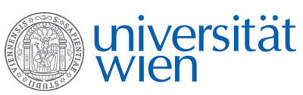 | Fakultät für Physik  Isotopenforschung und Kernphysik

E I N L A D U N G
zum

V E R A - S E M I N A R

von

Mariaelena Fedi

National Institute of Nuclear Physics (INFN)
Florence, Italy

Ten (+1) years of ¹⁴C-AMS at
INFN-LABEC, Florence

In 2004, thanks to the well-established expertise in application of nuclear techniques to the study of Cultural Heritage and exploiting the funding for a new tandem accelerator, the group of nuclear applied physicists in Florence gave birth to the LABEC laboratory. The mission of the laboratory was indeed to develop methods and tools, based on Ion Beam Analysis and Accelerator Mass Spectrometry, to be applied not only on archaeometry, but also on environment and material science in general. As for AMS, the activity of the laboratory has focused on radiocarbon. In this talk, I will give a review of the developments in ¹⁴C-AMS measurements in our laboratory, showing improvements both on hardware and on sample preparation procedures. Radiocarbon applications will also be discussed, highlighting the importance of this rare isotope for the authentication of artworks, as well as for “more traditional” studies in archaeology and history of art.

Donnerstag, 25. Juni 2015, 16:30 Uhr

1090 Wien, Währinger Str. 17, "Kavalierstrakt",
1. Stock, Victor-Franz-Hess-Hörsaal

R. Golser W. Kutschera E.M. Wild

