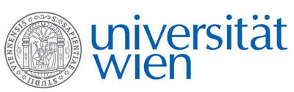 | Fakultät für Physik  Isotopenforschung und Kernphysik

E I N L A D U N G
zum

V E R A - S E M I N A R

von

Markus Plaschke

Karlsruher Institut für Technologie (KIT),
Institut für Nukleare Entsorgung (INE), Germany

Elemental and Isotope Analysis of
Nuclear Samples at KIT-INE

At KIT-INE a pool of advanced analytical techniques, well-developed procedures and competences in the fields of radiochemical sample handling and preparation, element and isotope analysis, chromatography and nuclear spectroscopy is available and applied for the R&D projects of the institute. Furthermore, analytical service is provided in the context of nuclear waste management, i.e., for nuclear waste treatment facilities, High Level Liquid Waste (HLLW) vitrification or decommissioning of nuclear installations. The first part of the talk will give an overview on these activities. The second part of the talk will focus on our contributions to field experiments investigating radionuclide migration and retention processes in deep geological formations, i.e., at the Grimsel Test Site (GTS) underground laboratory. Radionuclide “cocktails” equilibrated with bentonite colloids are directly injected into a hydraulically isolated shear-zone. The fate of the radionuclides (either attached to colloids or present as aqueous species) is monitored by on-site and off-site isotope and colloid analysis.

Donnerstag, 06. März 2014, 16:30 Uhr

1090 Wien, Währinger Str. 17, "Kavalierstrakt",
1. Stock, Victor-Franz-Hess-Hörsaal

R. Golser W. Kutschera E.M. Wild

