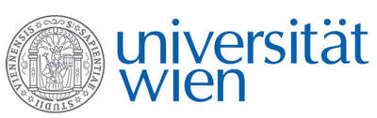 | Fakultät für Physik  Isotopenforschung und Kernphysik

E I N L A D U N G
zum

V E R A - S E M I N A R

von

Susan Trumbore

Max Planck Institute for Biogeochemistry, Jena

Timescales for carbon cycling in terrestrial ecosystems - what have we learned from
AMS Radiocarbon measurements?

Radiocarbon can be used to study carbon dynamics in terrestrial ecosystems on timescales ranging from years to decades (for 'bomb' ¹⁴C) to millennia (for cosmogenic ¹⁴C). This talk will provide examples of recent advances in understanding sources and stabilization mechanisms for soil organic matter, as well as controls on the age of CO₂ respired from ecosystems. I will focus on results from Amazonia, including the implications for a global carbon sink in intact tropical forests.

Donnerstag, 27. Juni 2013, 16:30 Uhr

1090 Wien, Währinger Str. 17, "Kavalierstrakt",
1. Stock, Victor-Franz-Hess Hörsaal

R. Golser W. Kutschera E.M. Wild

