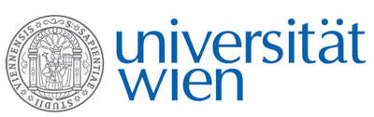 | Fakultät für Physik  Isotopenforschung und Kernphysik

E I N L A D U N G
zum

V E R A - S E M I N A R

von

Philippe COLLON

Physics Department, University of Notre Dame, Indiana, USA

Nuclear astrophysics at Notre Dame,
from MANTIS to St. George

Nuclear astrophysics has played a dominant role in the nuclear program at the Nuclear Science Laboratory (NSL) at the University of Notre Dame. In recent years a new Accelerator Mass Spectrometry program as well as the installation of a new Accelerator and Recoil Mass Spectrometer have opened new and exciting research possibilities.
The talk will not only present some of the new research tools at the NSL but also concentrate on the use of the gas-filled magnet technique used in conjunction with Accelerator Mass Spectrometry (AMS) to measure radionuclide concentrations and reaction cross–sections of importance in stellar nucleosynthesis and galactic radioactivities. Such a system (MANTIS = Magnet for Astrophysical Nucleosynthesis studies Through Isobar Separation) was set-up at the Nuclear Science Laboratory (NSL) at the University of Notre Dame together with graduate and undergraduate students and is used as an AMS system for the measurement of radioisotopes like ⁶⁰Fe and ⁹³Zr, as well as production cross sections such as ⁴⁰Ca(α,γ)⁴⁴Ti and ³³S(α,p)³⁶Cl. A number of future projects as well as some geared towards applied methods will also be presented.

Montag, 17. Juni 2013, 14 Uhr c.t.

1090 Wien, Währinger Str. 17, "Kavalierstrakt",
1. Stock, Victor-Franz-Hess Hörsaal

R. Golser W. Kutschera E.M. Wild

