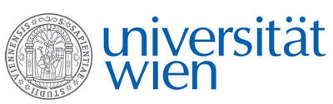 | Fakultät für Physik  Isotopenforschung und Kernphysik

E I N L A D U N G
zum

V E R A - S E M I N A R

von

Gary ZINKANN

Physics Division, Argonne National Laboratory, USA

Recent Developments and Future Plans
at the ATLAS Accelerator at Argonne

The Argonne Tandem Linac Accelerator System (ATLAS) is the world's first superconducting linear accelerator for heavy ions. Since the first successful acceleration of an ion beam by the prototype ATLAS facility in 1978, ATLAS has been growing and expanding its capability to provide unique and powerful beams for the world-wide nuclear and atomic physics research program. As a national user facility ATLAS has provided well over 55,000 hours of beam to the research community. Although ATLAS has been in operation for the past 31 years, it has been in a state of constant evolution both on accelerator technology and experimental target and detector technology. I will discuss the operations performance, the Californium Rare Ion Breeder Upgrade (CARIBU), the Energy Upgrade project and a new Helical Orbital Spectrometer that is presently underway at ATLAS.

Dienstag, 16. Juni 2009, 14:00 Uhr s.t.

1090 Wien, Währinger Str. 17, "Kavalierstrakt",
1. Stock, Victor-Franz-Hess-Hörsaal

R. Golser W. Kutschera

