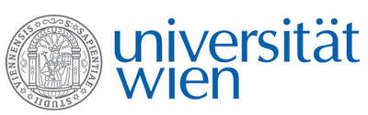 | Fakultät für Physik  Isotopenforschung und Kernphysik

E I N L A D U N G
zum

V E R A - S E M I N A R

von

Wladyslaw W. SZYMANSKI

Aerosol Physics, Biophysics and Environmental Physics
Fakultät für Physik, Universität Wien

Aerosol measurement over four orders of magnitude
in size - from nanoparticles to dust

Airborne micro- and nanoparticles are ubiquitous in ambient air influencing atmospheric processes and posing health hazards. They are also of substantial interest due to a variety of potential industrial applications. New developments for particle measuring and characterisation in the area of optical and electrostatic particle spectrometry will be presented. These techniques combined allow real-time measurement of particle sizes starting with about 1nm and spanning over four orders of magnitude. The Dual Wavelength Optical Particle Spectrometer (DWOPS) delivers next to accurate particle sizing the information about a key optical particle property – the complex refractive index. Based on this capability this device has a substantial prospective for atmospheric measurements and industrial monitoring applications. The electrophoretic particle mobility is utilized in the Parallel Differential Mobility Analyser (PDMA). This system allows measurement of nanoparticle size spectra but combined with mass spectrometry information on the density of nanoparticles can be obtained. Measurements on nanoparticles, dendrimeres and viruses will be discussed showing the potential of this technique for environmental and industrial applications.

Donnerstag, 13. März 2008, 16:30 Uhr

1090 Wien, Währinger Str. 17, "Kavalierstrakt",
1. Stock, Seminarraum von VERA

R. Golser W. Kutschera

