The location of the Arcotel Hotel Boltzmann, and the VERA Laboratory of the

Institute of Isotope Research and Nuclear Physics, University of Vienna

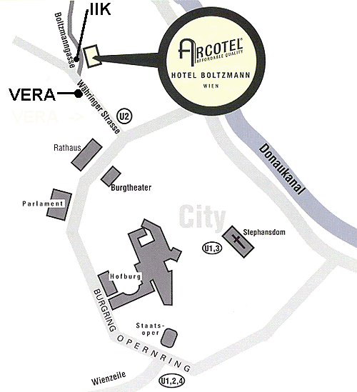

VERA = Vienna Environmental Research Accelerator (VERA Laboratory)
Institute for Isotope Research and Nuclear Physics, University of Vienna
Waehringer Straße 17, A-1090 Vienna Tel: +43-1-4277-51701
Fax: +43-1-4277-9517

Arcotel Hotel Boltzmann
Boltzmanngasse 8 Tel: +43-1-316 12-0
A-1090 Vienna Fax: +43-1-316 12-816
www.arcotel.at/boltzmann

